Name : Ida Bagus Ketut Yoghantara

Module : Front End Web Development

Class : BDSE04-0322

**Project Report**

1. **Project Background**

The background of this project is ‘ABC Learning Center’ need a website developer to develop a website for their institute. ‘ABC Learning Center’ is an IT Training institute that conducts courses like ‘Programming in Java’, ‘Programming in .Net’, ‘Microsoft Office’, ‘HTML’ etc. They want to design a website which can be used for providing information about their  
courses to students and for capturing leads generated by digital marketing.’

1. **Project Objectives**

* Website goals & Business goals

1. Responsive website that make better user experience for all website users
2. Easy to access and obtain the latest information
3. Improve company branding
4. Gather new leads with beautiful looking websites
5. Accessible 24/7

* Tools & platform used

1. Visual Studio Code

Visual Studio Code features a lightning fast source code editor, perfect for day-to-day use. With support for hundreds of languages, VS Code helps you be instantly productive with syntax highlighting, bracket-matching, auto-indentation, box-selection, snippets, and more.

1. Draw.io (diagrams.net)

Diagrams.net (formerly draw.io) is a free and open source cross-platform graph drawing software developed in HTML5 and JavaScript. Its interface can be used to create diagrams such as flowcharts, **wireframes**, UML diagrams, organizational charts, and network diagrams

1. Unsplash.com

Beautiful, free images and photos that you can download and use for any project. Better than any royalty free or stock photos.

1. Freepik.com

Find and download the best high-quality photos, designs and mockups · All the assets you need, in one place.

1. Figma.com

Figma is a vector graphics editor and prototyping tool which is primarily web-based, with additional offline features enabled by desktop applications for mac OS and Windows. The Figma mobile app for Android and iOS allow viewing and interacting with Figma.

1. Apache Tomcat 9.0

Apache Tomcat is a free and open-source implementation of the Jakarta Servlet, Jakarta Expression Language, and Web Socket technologies. Tomcat provides a "pure Java" HTTP web server environment in which Java code can run.

1. Font Awesome

Font Awesome is the Internet's icon library and toolkit, used by millions of designers, developers, and content creators.

1. **Requirement Specifications**

Developing a website using HTML, CSS, JavaScript, jQuery, and Ajax.

The requirement design of following website pages:

1. Common Content
2. Header
3. Footer
4. Navigation
5. Home Page
6. About Us Page
7. Course Listing Page (Listing 2 courses at least)
8. Course Details Page (Develop 2 pages, 1 for each course)
9. Course Schedule Page (Develop 2 pages, 1 for each course)
10. Contact Us Page (Develop 1 HTML page)
11. Lead Registration Page (Develop 1 form)
12. Registration Thank You Page (Develop 1 HTML page)
13. Lead Generation Administration Page
14. Sitemap Page (Develop 1 HTML page)
15. Privacy Policy Page (Develop 1 HTML page)
16. **Task 1**

Task Statement:

1. List and document features in a requirements specification document  
 a. Include sections for Website, Lead Generation form and its Administration.  
 2. Include it as part of Project Report.

Solution:

1. Common Content
2. Header

* Navigation bar
* Logo of company
* login & registration button

1. Footer

* Logo of company
* Links Company : About us, Our Team, Contact, Sitemap
* Links Program : Front-end developer, Back-end developer
* Links Follow Us : Twitter, Facebook, Instagram, YouTube
* Links Legal : Privacy Policy, Terms of service
* Copyright

1. Navigation

* Home, About, Course list, Front-end, Back-end, Contact

1. Home Page

* Hero banner
* Partners logo
* Student counter
* Why choose our company
* Course preview
* Join today banner

1. About Us Page

* Hero banner
* Partners logo
* Company history
* Our team member
* Join today banner

1. Course Listing Page (Listing 2 courses at least)

* Hero banner
* Tabs course listing

1. Course Details Page (Develop 2 pages, 1 for each course)

* Hero banner
* What will you get
* Course description
* FAQ (Frequently Asked Questions)
* What will you learn
* Student Testimonial

1. Course Schedule Page (Develop 2 pages, 1 for each course)

* Hero banner
* Course schedule

1. Contact Us Page (Develop 1 HTML page)

* Hero banner
* Contact information
* Contact form

1. Lead Registration Page (Develop 1 form)

* Registration form

1. Registration Thank You Page (Develop 1 HTML page)

* Thank you message

1. Administration Page (Admin only page)

* Menu
* Add, edit, delete, read table
* Search bar

1. Sitemap Page (Develop 1 HTML page)

* Hero banner
* Links to all the pages

1. Privacy Policy Page (Develop 1 HTML page)

* Hero banner
* Privacy policy statements

1. **Task 2**

Task Statement:

1. Create an Information Architecture & Storyboard for the website  
 2. Propose the Information flow for a Leads generation form & Its Administration (Login Not Required)  
 a. User must be able to Add, Edit, Delete & List leads  
 3. Include it as part of Project Presentation

Solution:

(Included in Project Presentation)

1. **Task 3**

Task Statement:

1. Develop the HTML Pages required for the website  
 2. Develop the Lead Generation Form & Administration System pages for Lead Generation form management.  
 3. Include the screen capture as part of Project Presentation

Solution:

(Included in Project Presentation)

1. **Task 4**

Task Statement:

1. Propose & use jQuery Components such as menu, popup etc. as part of the website.  
 2. Design the required HTML for jQuery Components.  
 3. Provide screen capture as part of Project Presentation.

Solution:

(Included in Project Presentation)

1. **Task 5**

Task Statement:

1. Write a paragraph on the effectiveness of the designed Lead Generation Administration System.  
 2. Write briefly on effectiveness of the User interface according to 2 metrics  
 3. Include it as part of Project Report.

Solution:

1. Lead generation is a method of sales and marketing that is initiated after a company sends a communication soliciting action from a user and is considered a substitution for cold calling a prospect. In other words, it's a part of a company's effort to transition a customer from a visitor of a website to an avid buyer and user of the product.   
  
 We as the ABC Learning Center will use our brand new website to get as many users that interested in our services and capture their lead information to get potential learners or customers.

The home page is set up as a landing page, complete with an image, a button, and a compelling message or offer to entice website users to click on it. The visitor will then quickly fill out a Lead Generation Form.

After that, the lead information is saved for further processing.

After completing the form, the visitor will be forwarded to the course listing page, where they will be informed about upcoming courses that may be of interest to them. Lead information can also be collected via the website's Contact Us form.

The ABC Learning Center sales staff can use the Lead Administration System to follow up on the produced leads.

2. **Metrics for Lead Generation Form**

* No more than 3 minutes required to fill the Lead Registration Form.
* Lower error rate because the registration form has validation feature to avoid unwanted information or error.
* Responsive UI will make user comfortable and have a good experience when they filling the form

1. **Task 6**

Task Statement:

1. Make changes to User Interface based on effectiveness metrics identified in Task 5.  
 2. Make the changes to HTML, CSS & JavaScript.  
 3. Include the screen capture along with list of modifications made as part of Project  
 Presentation.

Solution:

(Included in Project Presentation)

1. **Task 7**

Task Statement:

1. Create a User Guide for Lead Generation form and its Associated Administration  
 Module.  
 2. Include it as part of Project Report

Solution:

**User Guide:**

* 1. Register button/Join today button



For registration/lead generation form, user can click on the register button in navigation bar on the top of the website or user can click on the join today button on the bottom of the pages and user will be directed to registration form.

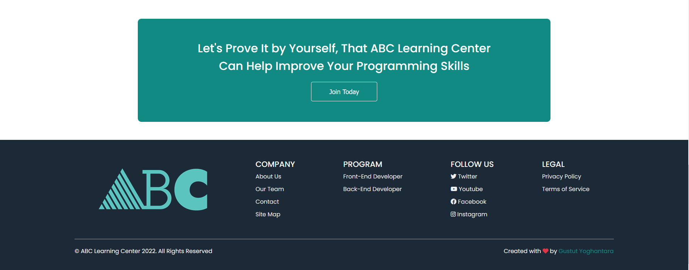

* 2. Lead Generation Form

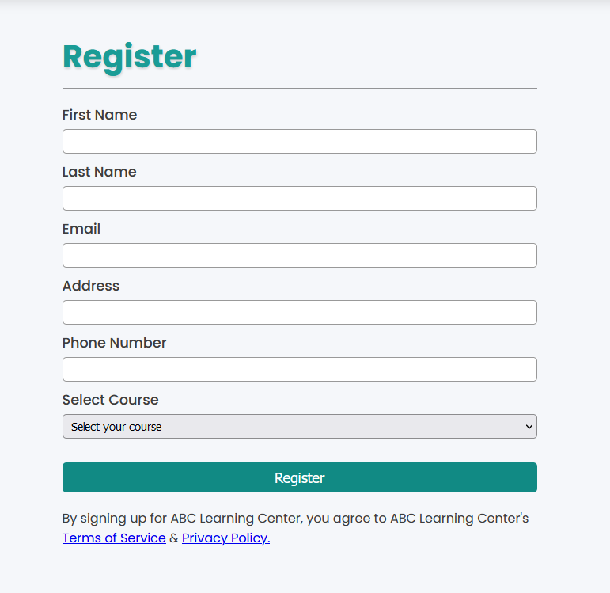

For registration form, user need to fill all the input field to create an account according to their own information (please don’t fill it with fake information).

* 3. Thank You page

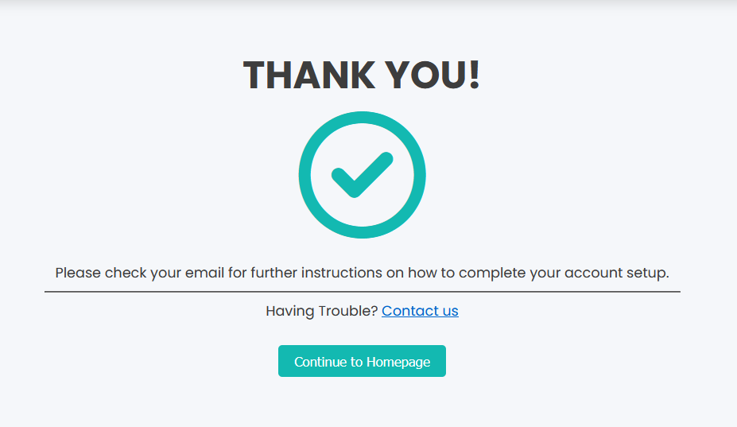

After filling the form user can submit it and confirm prompt box will pop up. User will be directed to thank you page after they finish filling the registration form.

**Administration System Guide :**

* 1. Admin page

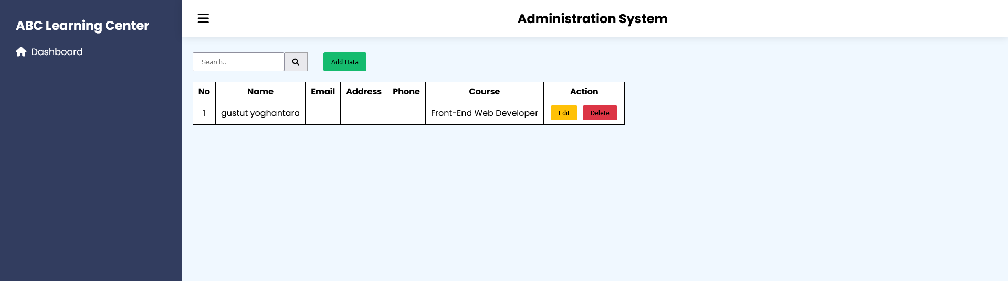

Administrator can go to “localhost:8080/Project/admin.html” to access the administration system page

* 2. Add, Edit, Delete, Search lead generation data

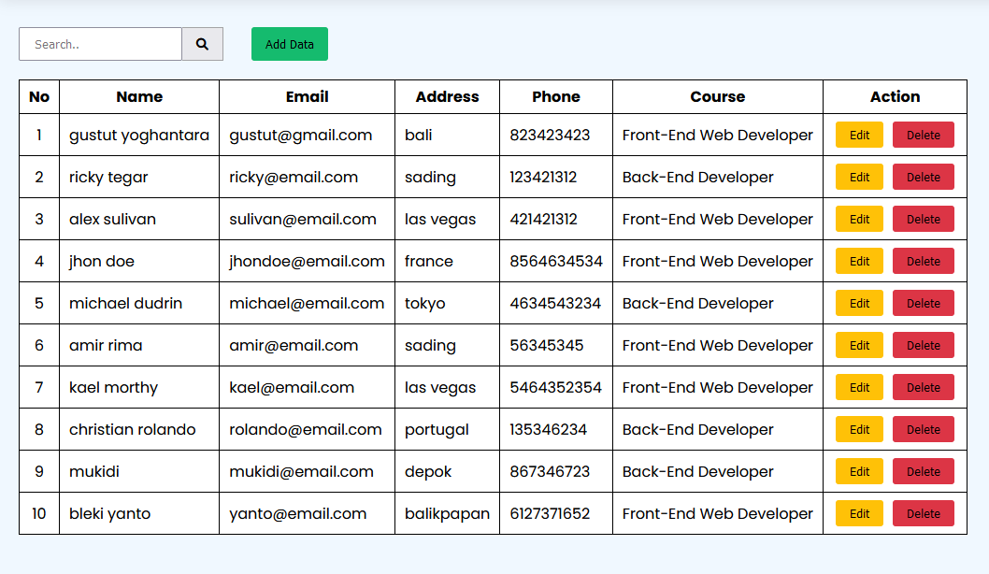

Delete Data

Edit Data

Add Data

Search by name

* 3. Add lead generation data

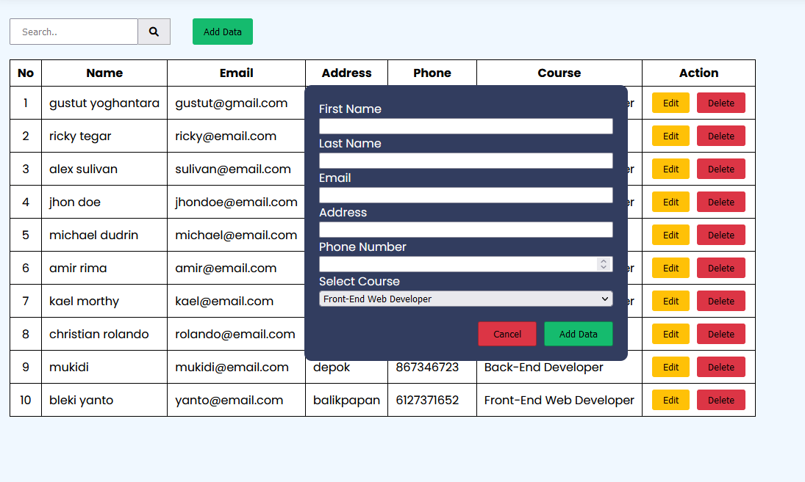

Click add data button and fill the add data form to add the new data. Click add data and the new data will added

* 4. Edit lead generation data

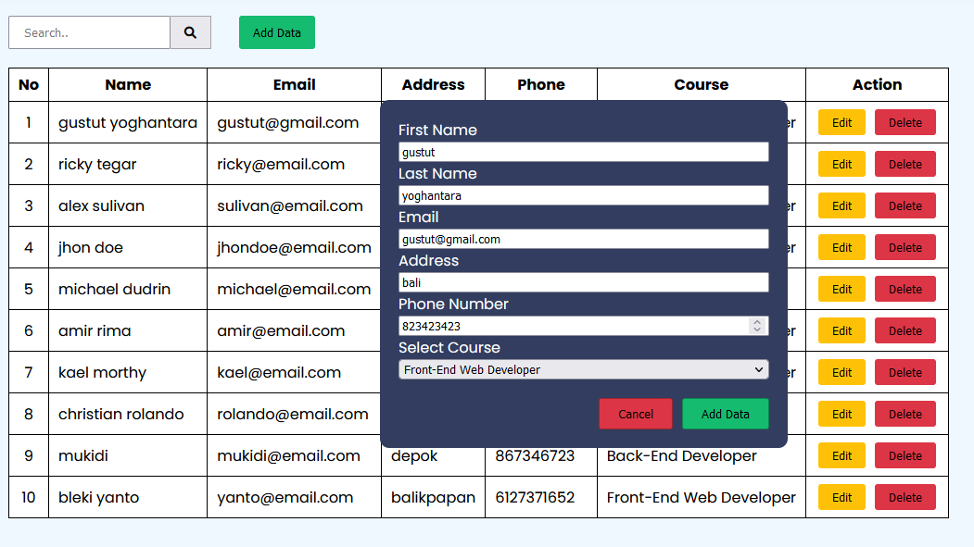

Click edit data button and form data with that particular value of the targeted data will appear on the form data. After editing the data, click add data to add the edited data.

* 5. Search

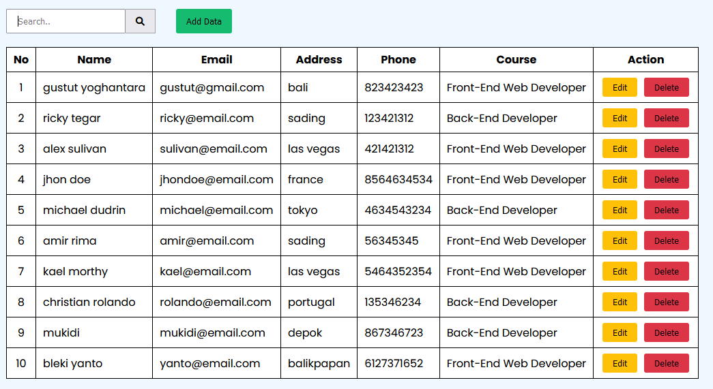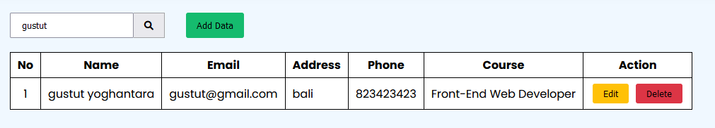

The searchbar is filtered by name, you can type lead generation data by their name to search any specific name you want.

* 6. Delete data

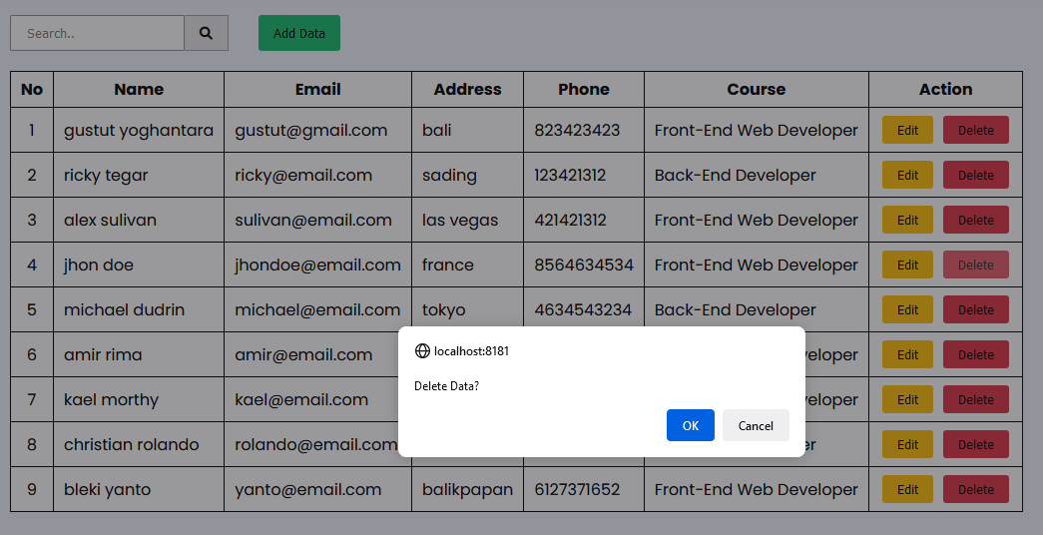

Clicking the delete button will popup a confirmation popup, click ok to delete the data or click cancel to cancel.